|  |  |  |  |
| --- | --- | --- | --- |
| Pipe Joint Without Defect | C:\Users\Shravan\Google Drive\Shared with Dell\Team SewerPipe\Programs\Main\data\1 Pipe joint without defect\PJwD_0007.png | C:\Users\Shravan\Google Drive\Shared with Dell\Team SewerPipe\Programs\Main\data\1 Pipe joint without defect\PJwD_2294.png | C:\Users\Shravan\Google Drive\Shared with Dell\Team SewerPipe\Programs\Main\data\1 Pipe joint without defect\PJwD_2211.png |
| Pipe crack | C:\Users\Shravan\Google Drive\Shared with Dell\Team SewerPipe\Programs\Main\data\4 Pipe crack\PipeCrack_0037.png | C:\Users\Shravan\Google Drive\Shared with Dell\Team SewerPipe\Programs\Main\data\4 Pipe crack\PipeCrack_0234.png | C:\Users\Shravan\Google Drive\Shared with Dell\Team SewerPipe\Programs\Main\data\4 Pipe crack\PipeCrack_1499.png |
| Side pipe zoomed | C:\Users\Shravan\Google Drive\Shared with Dell\Team SewerPipe\Programs\Main\data\7 Side pipe zoomed\SPZ_0132.png | C:\Users\Shravan\Google Drive\Shared with Dell\Team SewerPipe\Programs\Main\data\7 Side pipe zoomed\SPZ_0592.png | C:\Users\Shravan\Google Drive\Shared with Dell\Team SewerPipe\Programs\Main\data\7 Side pipe zoomed\SPZ_0730.png |
| Pipe joint + side pipe | C:\Users\Shravan\Google Drive\Shared with Dell\Team SewerPipe\Programs\Main\data\6 Pipe joint + side pipe\PJSP_0052.png | C:\Users\Shravan\Google Drive\Shared with Dell\Team SewerPipe\Programs\Main\data\6 Pipe joint + side pipe\PJSP_0109.png | C:\Users\Shravan\Google Drive\Shared with Dell\Team SewerPipe\Programs\Main\data\6 Pipe joint + side pipe\PJSP_0199.png |
| Manhole | C:\Users\Shravan\Google Drive\Shared with Dell\Team SewerPipe\Programs\Main\data\9 Manhole\ManHole_0502.png | C:\Users\Shravan\Google Drive\Shared with Dell\Team SewerPipe\Programs\Main\data\9 Manhole\ManHole_0757.png | C:\Users\Shravan\Google Drive\Shared with Dell\Team SewerPipe\Programs\Main\data\9 Manhole\ManHole_1042.png |
| Debris | C:\Users\Shravan\Google Drive\Shared with Dell\Team SewerPipe\Programs\Main\data\10 Debris\Debris_0022.png | C:\Users\Shravan\Google Drive\Shared with Dell\Team SewerPipe\Programs\Main\data\10 Debris\Debris_0454.png | C:\Users\Shravan\Google Drive\Shared with Dell\Team SewerPipe\Programs\Main\data\10 Debris\Debris_1663.png |
| Corrosion | C:\Users\Shravan\Google Drive\Shared with Dell\Team SewerPipe\Programs\Main\data\11 Corrosion\Corrosion_0005.png | C:\Users\Shravan\Google Drive\Shared with Dell\Team SewerPipe\Programs\Main\data\11 Corrosion\Corrosion_0830.png | C:\Users\Shravan\Google Drive\Shared with Dell\Team SewerPipe\Programs\Main\data\11 Corrosion\Corrosion_0452.png |
| Calcinated | C:\Users\Shravan\Google Drive\Shared with Dell\Team SewerPipe\Programs\Main\data\16 Calcinated\Calcinated_1418.png | C:\Users\Shravan\Google Drive\Shared with Dell\Team SewerPipe\Programs\Main\data\16 Calcinated\Calcinated_1694.png | C:\Users\Shravan\Google Drive\Shared with Dell\Team SewerPipe\Programs\Main\data\16 Calcinated\Calcinated_0053.png |
| Text images | C:\Users\Shravan\Google Drive\Shared with Dell\Team SewerPipe\Programs\Main\data\17 Text images\Text images_0025.png | C:\Users\Shravan\Google Drive\Shared with Dell\Team SewerPipe\Programs\Main\data\17 Text images\Text images_0471.png | C:\Users\Shravan\Google Drive\Shared with Dell\Team SewerPipe\Programs\Main\data\17 Text images\Text images_0225.png |

**Inpainting Results**

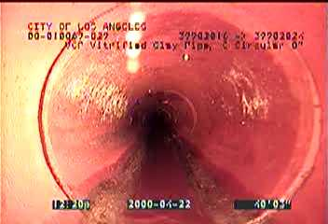 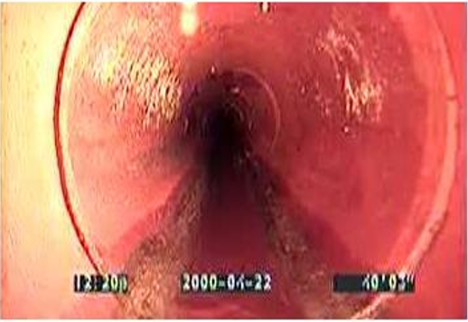­

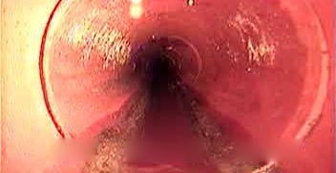

**Eigen Plot Thresholding**:

